THE SKAPONES
NORTH EAST SKA

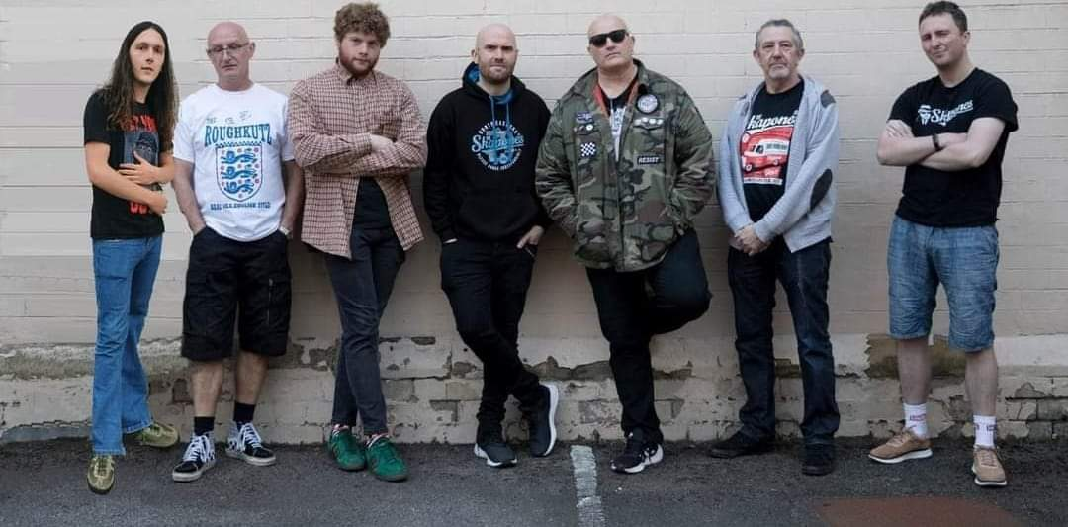
www.theskapones.co.uk www.facebook.com/theskapones www.twitter.com/skapones
www.instagram.com/theskapones www.theskapones.bandcamp.com
https://www.youtube.com/channel/UCumud9pWllVaqTT3aE4OTSg
Contact Paul Williams 07706881396 email- paulwillo1@hotmail.com

The band together one day back in 2013 in the deepest darkest part of Darlington, the market town based in the Tees Valley in the north east of England.
The band are currently celebrating their 10th Anniversary in 2023
Some of the highlights in that 10 years include:
- Running their own record label
- Producing their own material and releasing vinyl, CD and digital downloads
- Completely DIY – No management
- Played across UK, Ireland, Europe and America
- Supported many music legends
- Toured with The Specials and The Beat.
- Released a book about their 2019 USA TOUR
- Played 100s of gigs and festivals
- Played in front of 75,000 at Trafalgar Square
- 19 singles released
- 4 albums
- Umpteen compilation album appearances
- Never played Glastonbury
- Proud to be self managed and self sufficient.

